**A WRITTEN DRAFT OF THE WORK DONE SO FAR**

The objective of this draft is to summarize the preliminary analysis of the effect local businesses and entities (like hospital, condos, and residential areas) on NRG evGo Electric Vehicle (EV) charging stations usage in the greater Houston area. Our hypothesis is that entities have positive and negative impacts on EV station usage.

For our study, we used data from two sources:

1. **NRG evGo Charging data:** Data used was station identification number, date/time used, and latitude/longitude of the station.

1. **Harris County data**

The Harris County data includes real buildings data (available in 4 relevant text files) and a shapefile (in json format) showing the location for all buildings in the county.

**Harris County Real Buildings data:** This data was obtained from the Harris County Appraisal District website <http://pdata.hcad.org/download/index.html> . Since we are trying to analyze the effect of local environmental variables on the demand of a charging station, the data that we were interested in, for our analysis was the Harris County real buildings data. Data, which is to be used in the model includes:

1. building type/use code,
2. sq. ft. area,
3. appraised property value,
4. number of units in a building.

This information is contained in four separate files- **Building_res.txt**, **Builing_other.txt**, **Extra_features_detail1.txt** and **Extra_features_detail2.txt**.

All these files have a unique HCAD (account) number for each building, which was merged to the shapefile. Thus far, for our preliminary analysis, we have only been using the Building Type/Use code as a variable to study the demand of charging stations.

**Harris County Polygon Data**: The Harris County Shapefile data (in json format) provides information regarding the geographical coordinates and physical address of a building associated with a particular HCAD number. The information about the HCAD number was especially important for us as it allowed us to map the features obtained from the Harris County Real Buildings Data to a geographical location.

1. **Classification of Building Type/Use codes:** There are in all around 180 building type (impv_type) codes in the files. For the purpose of our study, we grouped all these building type codes into 19 different categories, namely:
2. Residential buildings,
3. Offices,
4. Industrial buildings,
5. Warehouses,
6. Shopping centers,
7. Restaurants,
8. Recreation centers,
9. Movie halls/Theaters,
10. Social/Cultural halls,
11. Medical Center,
12. Service Stations,
13. Banks,
14. Transport
15. Terminals,
16. Emergency stations,
17. Libraries,
18. Religious centers,
19. Car dealerships,
20. Public Utility Infrastructure companies
21. Amusement Parks .

These categories aggregate similar types of buildings together. However, taking into account the categories made so far, we agree that there is still some scope of improvement in the classification scheme.

1. **Making the study area environmental variables:** To analyze the effect of environmental variables, we divided the Harris County into a grid consisting of squares of sizes 10,000 x 10,000 sq. ft each and then summed the different features like total number of residential buildings/offices/shopping centers/restaurants etc. for each square in the grid. Below is an example of the grid system layout.

|  |  |  |  |
| --- | --- | --- | --- |
| 1 | 1 | 2 | 1 |
| 2 | 3 | 2 | 3 |
| 2 | 2 | 1 | 2 |
| 1 | 3 | 2 | 3 |

By mapping the coordinates of each charging station, we located the grid square to which the charging station belonged. Subsequently, the corresponding totals for each grid square for each feature were extracted. This provided regression analysis the independent variables for charging station demand.

We note here that dividing the city into a square grid and extracting features for each square in the grid is especially useful in achieving our final objective, which is - to be able to predict the demand of a charging station if placed at any new location in the city. Since it is very likely that the charging station within a square will not be located in the centre of a grid square, therefore, in general, because of asymmetry, we cannot assume that the features in the grid square will represent that charging station perfectly.

Therefore, as a next step, we propose to first map the location of a charging station and then consider the aggregated features in a circular of region of about 2 mile radius for regression analysis.

1. **Regression analysis:** For our regression analysis, we considered the response variable to be the number of monthly transactions for a charging station in month t, where t=0 was assumed to be the time period from the first transaction. We used the NRG eVgo DC Charging stations’ transactions data to extract the values of the response number of monthly for the set of independent environmental variables obtained from step 4.

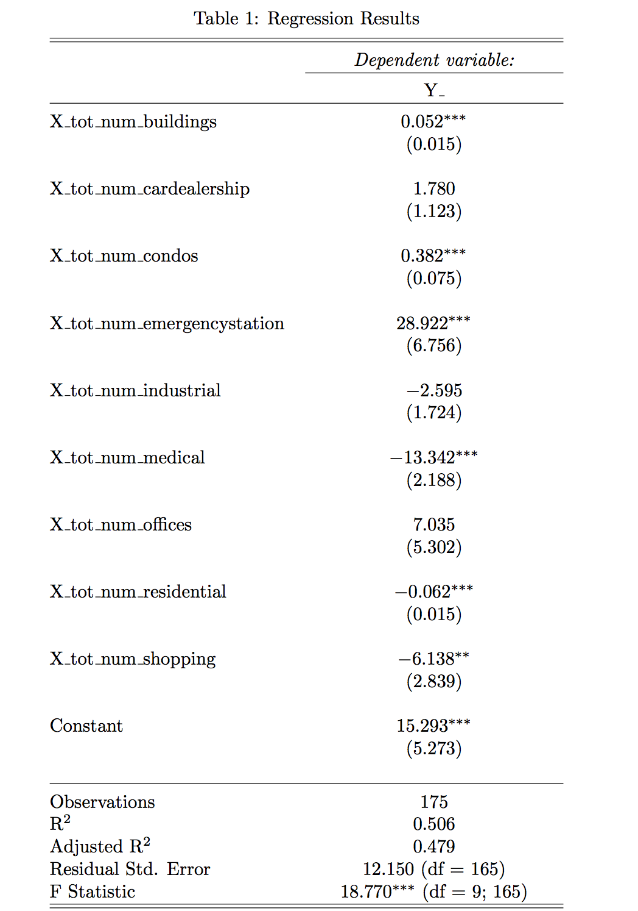

1. **Next steps**

Some of the next steps on which we plan to work on are:

1. Considering a circular region of 1 mile radius around the charging station and doing analysis for that region (instead of square grid system currently being used) could be tried out next.
2. Dependence on the operational time of charging stations and introduction of other independent variables like property value, sq. ft. area and number of units (proxy for the number of people working/residing) in buildings could also be considered.
3. Other forecasting methods based on Support Vector Regression and Neural Networks could be tried out next.
4. Some of the charging stations were found to be outside the domain of Harris County and hence, values of environmental variables for those charging stations could not be determined. Thus, we plan to use extract data for other counties in a similar way and use it for the analysis of the missed out charging stations.
5. As mentioned before, some modifications could also be made to the classification scheme of building types and new results could be obtained accordingly.
6. Use the results obtained from regression analysis to predict how the demand of a charging station will be at a new location within the city.